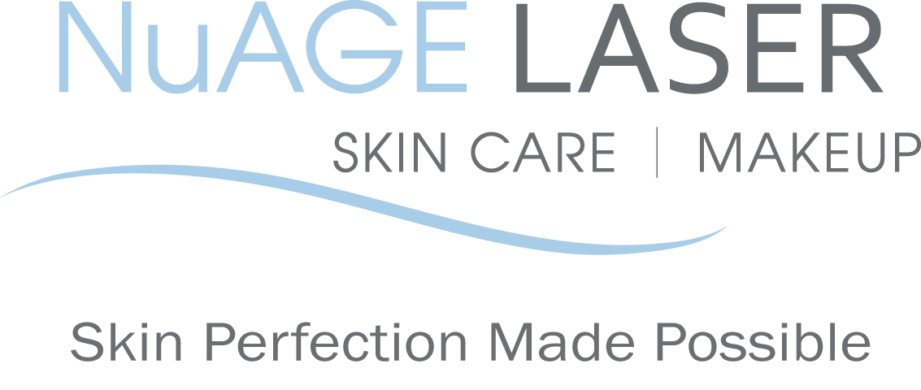
Laser for Acne Scars - pre & post care instructions

BEFORE your treatment:

- Do not wear makeup prior to your treatment.
- Avoid anything that may irritate to your skin. This includes refraining from using products containing Retin-A, retinol, benzoyl peroxide, glycolic/salicylic acids, astringents or Vitamin C for at least two weeks before your treatment.
- 3.Do not wax or use a depilatory on treatment areas for 2 week prior to your treatment.

AFTER your treatment:

- Avoid sun exposure and tanning beds to treated areas after treatment (although we recommend you refrain from both in general!). Daily sunscreen with an SPF of at least 30 is vital to maintain your new healthy skin.
- Avoid any irritants to your skin, such as any products containing Retin-A, retinol, benzoyl peroxide, glycolic/salicylic acids, astringents or Vitamin C for at least one week after your treatment. This will allow ample time for the skin to heal.
- Do not wax, tweeze or use a depilatory to the treated areas for two weeks after your treatment.
- Localized redness may be present and typically resolves within 24 to 48 hours.
- The Acne scars will first appear redder than before, but will begin to fade.
- Do not put on makeup until the next day post treatment.

NAME: __________________________ DATE: ___________________________

SIGNATURE: ______________________

Please call us if you have any questions at 604-682-4645

Your referrals are greatly appreciated. We will send you a $50 gift certificate towards your next treatment for each friend or relative that you refer to us.

2014 NuAGE Laser, Skin Care & Makeup. All rights reserved. Program materials may not be reproduced in any form without the prior Permission of NuAGE Laser.

