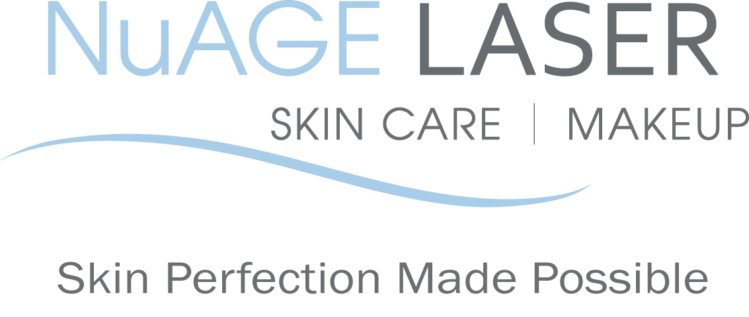
Laser Treatment – Restoring Clear Nails
Post & Pre Care

Pre Care:
  - Remove all polish & anti-fungus ointment before your scheduled appointment.
  - Bring a fresh pair of socks with you to wear after your nail fungus laser treatment.
Post Care & to help prevent reinfection:
  - Wear clean shoes/socks home after treatment.
  - Wash sheets; disinfect shower/bath, and vacuum carpets day of treatment.
  - Wear comfortable shoes that fit well.
  - Change your socks every day. If excessive perspiration occurs, change your socks twice per day. Wear moisture-wicking socks, if possible, to help keep your feet dry.
  - Apply anti-fungal tincture 2x per day for approximately 2 weeks to 3 months depending on the severity of the infection.
  - Apply anti-fungal powder to all shoes at least 1x per week for at least 1 month.
  - Soak the feet in a vinegar solution twice per week:
7 tbsp. vinegar mixed in 2L of warm water - Soak for 20 minutes, then dry the skin and the nails completely. You may also add Epsom salts to the vinegar solution.
- Avoid walking barefoot in public places (pool, gym, etc.). Always wear flip-flops in pool/shower areas.
- Do not share socks, shoes, or towels with others.
- Fungus likes to grow in dark, damp, warm climates. By eliminating any of these 3 factors you help achieve faster results and prevent re-infection. Allow your feet to get light and air when possible and avoid wearing dampened shoes; you may alternate shoes every other day to allow them to fully dry. Any moisture creates the perfect environment for nail fungus to flourish.
- Wash your socks separately with bleach added to every load.
- Nail polish may be applied 24hrs after treatment
- The average time interval between treatments is 6 weeks.
- Due to slow nail growth, results may not be noticeable for 3+ months. Toenails may take 9-12 months, and fingernails may take 6-9 months to grow out. Severely infected nails may take longer.

NAME: __________________________ DATE: ___________________________

SIGNATURE: ______________________

Please call us if you have any questions at 604-682-4645

Your referrals are greatly appreciated. We will send you a $50 gift certificate towards your next treatment for each friend or relative that you refer to us.

2014 NuAGE Laser, Skin Care & Makeup. All rights reserved. Program materials may not be reproduced in any form without the prior Permission of NuAGE Laser.

