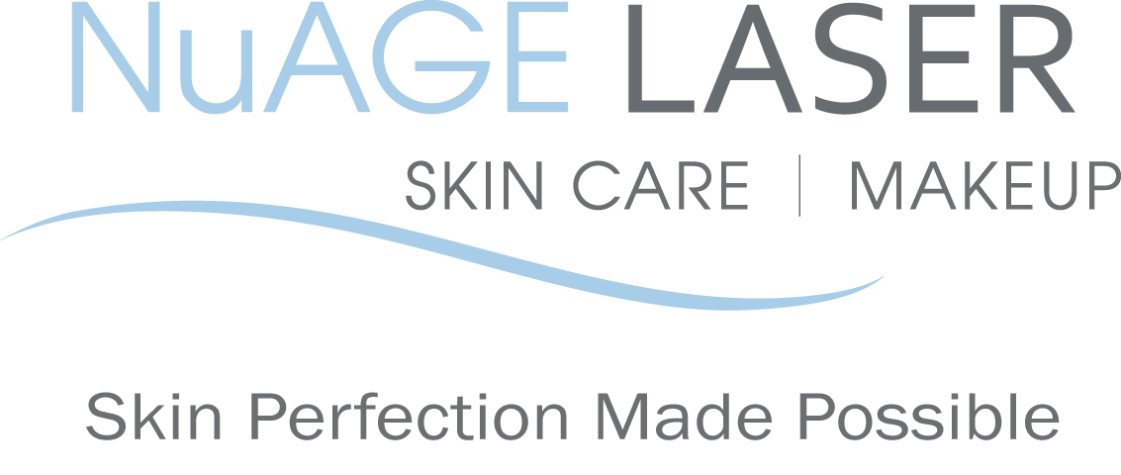
Post & pre-care instructions for
TITAN-Laser Skin Tightening

BEFORE your treatment:

1. Do not wear makeup to your treatment.
2. Avoid any irritants to your skin. such as any products containing Retin-A, retinol, benzoyl peroxide, glycolic/salicylic acids, astringents or Vitamin C for one week before your treatment.
3. Do not wax or use a depilatory on treatment areas for 1 week prior to your treatment.
AFTER your treatment:
1. Avoid sun exposure and tanning beds to treated areas after treatment (although we recommend you shouldn’t be using a tanning bed anyway Beauty Gal!). Daily sunscreen with an SPF of at least 30 is vital to maintain your improved skin.
2. Avoid any irritants to your skin, such as any products containing Retin-A, retinol, benzoyl peroxide, glycolic/salicylic acids, astringents or Vitamin C for one week after your treatment.
3. Do not wax, tweeze or use a depilatory to the treated areas for one week after your treatment.

NAME: __________________________ DATE: ___________________________

SIGNATURE: ______________________

Please call us if you have any questions at 604-682-4645

Your referrals are greatly appreciated. We will send you a $50 gift certificate towards your next treatment for each friend or relative that you refer to us.

2014 NuAGE Laser, Skin Care & Makeup. All rights reserved. Program materials may not be reproduced in any form without the prior Permission of NuAGE Laser.

