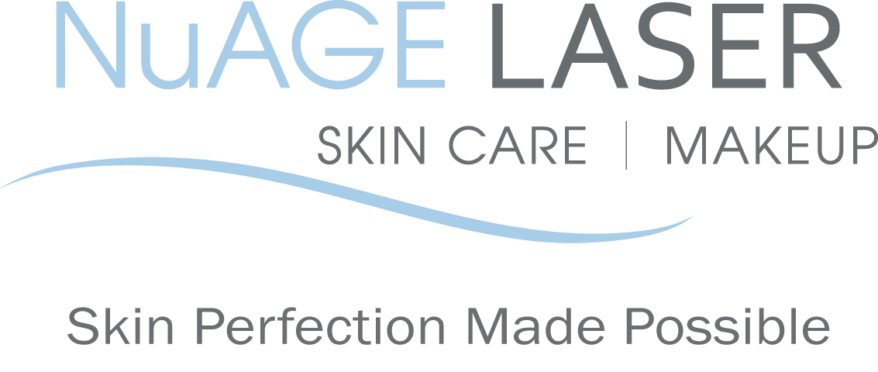
Laser Hair Removal Pre & Post Care Instructions

BEFORE your laser treatment:

1. Must shave the area that is to be treated prior to your appointment. It’s best to shave as close to your scheduled appointment as possible; shave in the shower as it delivers the closest shave. The closer the shave the less chance of skin irritation post treatment.

2. Use sunscreen daily, sun burned skin cannot be treated.

3. Avoid any irritants to your face, such as any products containing Hydroquinone, bleaching creams, Retin-A, retinol, benzoyl peroxide, glycolic/salicylic acids or astringents for at least 2 weeks.

4. Do not use self-tanning agents for at least two weeks before any treatment. If you have used these products, thoroughly cleanse the area with abrasive/exfoliating scrubs to remove all product two weeks prior to any treatment.

5. DO NOT pluck or wax for at least 1 month prior to your first treatment, continuing through the course of your treatments. Plucking/waxing removes the target hair. DO NOT bleach or use “Nair”-type products for 2 weeks prior to treatment, this can irritate or burn the skin.
6. DO NOT wear any make-up, perfume or lotions in the treatment area prior to your treatment.
7. Before each laser hair removal treatment, please inform us if you are taking any new antibiotics or medications, as they may make your skin photosensitive and therefore we may not be able to treat you for one to two weeks after completion of antibiotic.

8. Advil or Motrin can be helpful if you are feeling uneasy. Numbing cream may also be applied 1 hour prior the laser removal treatment to reduce anxiety.
AFTER your laser treatment:

1. If treating the face, please continue using sunscreen daily for the entire treatment period.

2. Until initial skin irritation subsides, avoid hot water and anything irritating to the skin. You may apply Aloe Vera.
3. Avoid any irritants to your face, such as any products containing Retin-A, retinol, benzoyl peroxide, glycolic/salicylic acids or astringents for at least 2 days.
4. Do not wear tight, constricting clothing in the treated area as irritation can occur and skin cannot cool properly.

5. Do not exercise, receive any body treatments, take hot showers, use saunas or hot tubs until skin is back to normal.
6. If you have razor bumps or ingrown hairs you may exfoliate the area twice weekly until they are gone.

NAME: __________________________ DATE: ___________________________

SIGNATURE: ______________________

Please call us if you have any questions at 604-682-4645

Your referrals are greatly appreciated. We will send you a $50 gift certificate towards your next treatment for each friend or relative that you refer to us.

2014 NuAGE Laser, Skin Care & Makeup. All rights reserved. Program materials may not be reproduced in any form without the prior Permission of NuAGE Laser.

