IPL pre & post care instructions
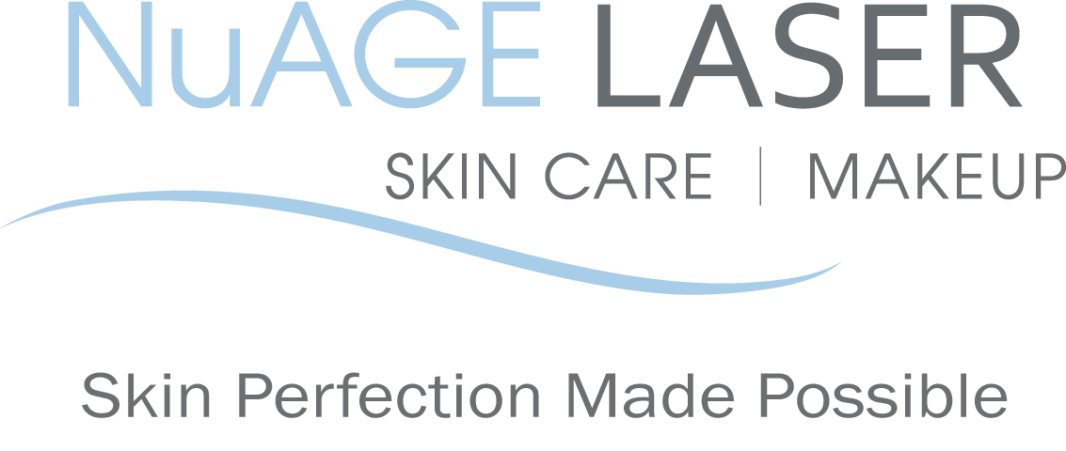
Laser Treatment for Dark Spots & Sunspot

BEFORE your IPL treatment:

1. Do NOT wear makeup to your treatment.
2. Avoid any irritants to your skin. such as any products containing Retin-A, retinol, benzoyl peroxide, glycolic/salicylic acids, astringents or Vitamin C for one week before your treatment

3. Do not wax or use a depilatory on treatment areas for 1 week prior to your treatment.

AFTER your IPL treatment:

1. Avoid sun exposure and tanning beds to treated areas after treatment (we recommend this indefinitely). Daily sunscreen with an SPF of at least 30 is vital to maintain your improved skin.

2. Avoid any irritants to your skin, such as any products containing Retin-A, retinol, benzoyl peroxide, glycolic/salicylic acids, astringents or Vitamin C for one week after your treatment.
3. Do not wax, tweeze or use a depilatory to the treated areas for one week after your treatment.

4. Treated lentigines usually darken after treatment, and crusting begins to form within a few days. This crusting usually resolves in 3-7 days. Do not pick or pull at this, as the skin is healing.

5. Exfoliation is highly recommended as it helps slough off the surfaced pigment in half the time. Our Micro-peel exfoliant is soothing and yet abrasive enough to give you the best results in a shorter time.

6. If significant crusting occurs beyond the normal flaking of the treated lesions, an antibiotic ointment such as Polysporin or Bacitracin may be recommended.
7. Localized redness may be present and typically resolves within 24 to 48 hours.

8. To allow maximum healing, try not to wear makeup until the following morning post treatment.

NAME: __________________________ DATE: ___________________________

SIGNATURE: ______________________

Please call us if you have any questions at 604-682-4645

Your referrals are greatly appreciated. We will send you a $50 gift certificate towards your next treatment for each friend or relative that you refer to us.

2014 NuAGE Laser, Skin Care & Makeup. All rights reserved. Program materials may not be reproduced in any form without the prior Permission of NuAGE Laser.

