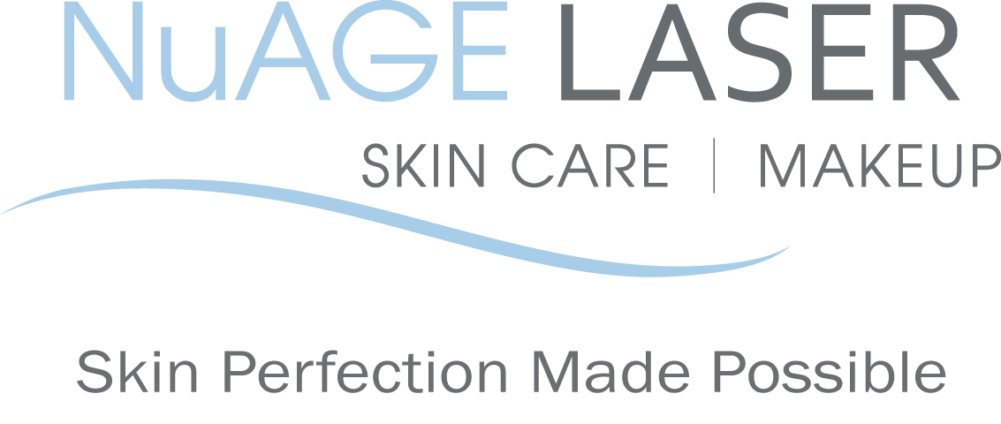
Chemical Peel Facial - Pre & Post Care Instructions

BEFORE your chemical peel treatment:
1. Do not wear makeup to your chemical peel treatment.
2. Avoid any irritants to your skin. such as any products containing Retin-A, retinol, benzoyl peroxide, glycolic/salicylic acids, astringents or Vitamin C for one week before your chemical peel treatment.
3. Do not wax or use a depilatory on treatment areas for 1 week prior to your chemical peel treatment.
AFTER your chemical peel treatment:

1. Avoid sun exposure and tanning beds to treated areas after chemical peel treatment (we recommend this indefinitely). Daily sunscreen with an SPF of at least 30 is vital to maintain your improved skin.
2. Avoid any irritants to your skin, such as any products containing Retin-A, retinol, benzoyl peroxide, glycolic/salicylic acids, astringents or Vitamin C for one week after your chemical peel treatment.
3. Do not wax, tweeze or use a depilatory to the treated areas for one week after your chemical peel treatment.
4. Wait until the next morning to reapply makeup.
5. Approximately 48 hours after treatment, your skin may start to peel. This peeling will generally last 2 to 3 days. DO NOT PICK OR PULL THE SKIN.

Our Resurfacing exfoliating pads or Micro-peel exfoliant are recommended as home-care to decongest the skin even further for ultimate results and to relieve peeling.

NAME: __________________________ DATE: ___________________________

SIGNATURE: ______________________

Please call us if you have any questions at 604-682-4645

Your referrals are greatly appreciated. We will send you a $50 gift certificate towards your next treatment for each friend or relative that you refer to us.

2014 NuAGE Laser, Skin Care & Makeup. All rights reserved. Program materials may not be reproduced in any form without the prior Permission of NuAGE Laser.

